**Experiment Name:** Introduction with the necessary components required in Communication Engineering Laboratory

**Objective:** To Introduce with the necessary components required in Communication Engineering Laboratory

**Requirements:**

1. Frequency Modulator/Demodulator Trainer, IT-4103
2. AM DSB/SSB RECEIVER TRAINER, IT-1102
3. Pulse Code Modulation (PCM) Receiver Trainer, IT-4204
4. Time Division Multiplexing Transceiver Trainer IT-4202,
5. AM DSB/SSB TRANSMITTER TRAINER IT-4101
6. SIGNAL SAMPLING & RECONSTRUCTION TRAINER IT-2201
7. Pulse Code Modulation Transmitter Trainer IT-4203

**1. Frequency Modulator/Demodulator Trainer. IT-4103**

* **Audio Generator:** Adjustable for frequency and amplitude, used for generating audio signals.
* **Reactance Modulator:** Modulates the frequency of signals using an oscillator.
* **Varactor Modulator:** Utilizes a varactor diode for electronic tuning and frequency modulation.
* **Detuned Resonant Circuit:** Operates a resonant circuit that is detuned.
* **Quadrature Detector:** Detects modulated frequencies by creating a phase shift.
* **Foster-Seely Detector:** Uses a discriminator circuit to demodulate FM signals.
* **Ratio Detector:** Another type of discriminator that’s less prone to amplitude variations.
* **Phase Locked Loop:** A control system that locks the output frequency to a reference frequency.
* **Low Pass Filter:** With a 3.4 kHz cutoff frequency, it allows only signals below this frequency to pass.
* **AC Amplifier:** Amplifies AC signals and includes an adjustable gain feature.
* **Amplitude Limiter:** Limits the amplitude of signals to prevent distortion.

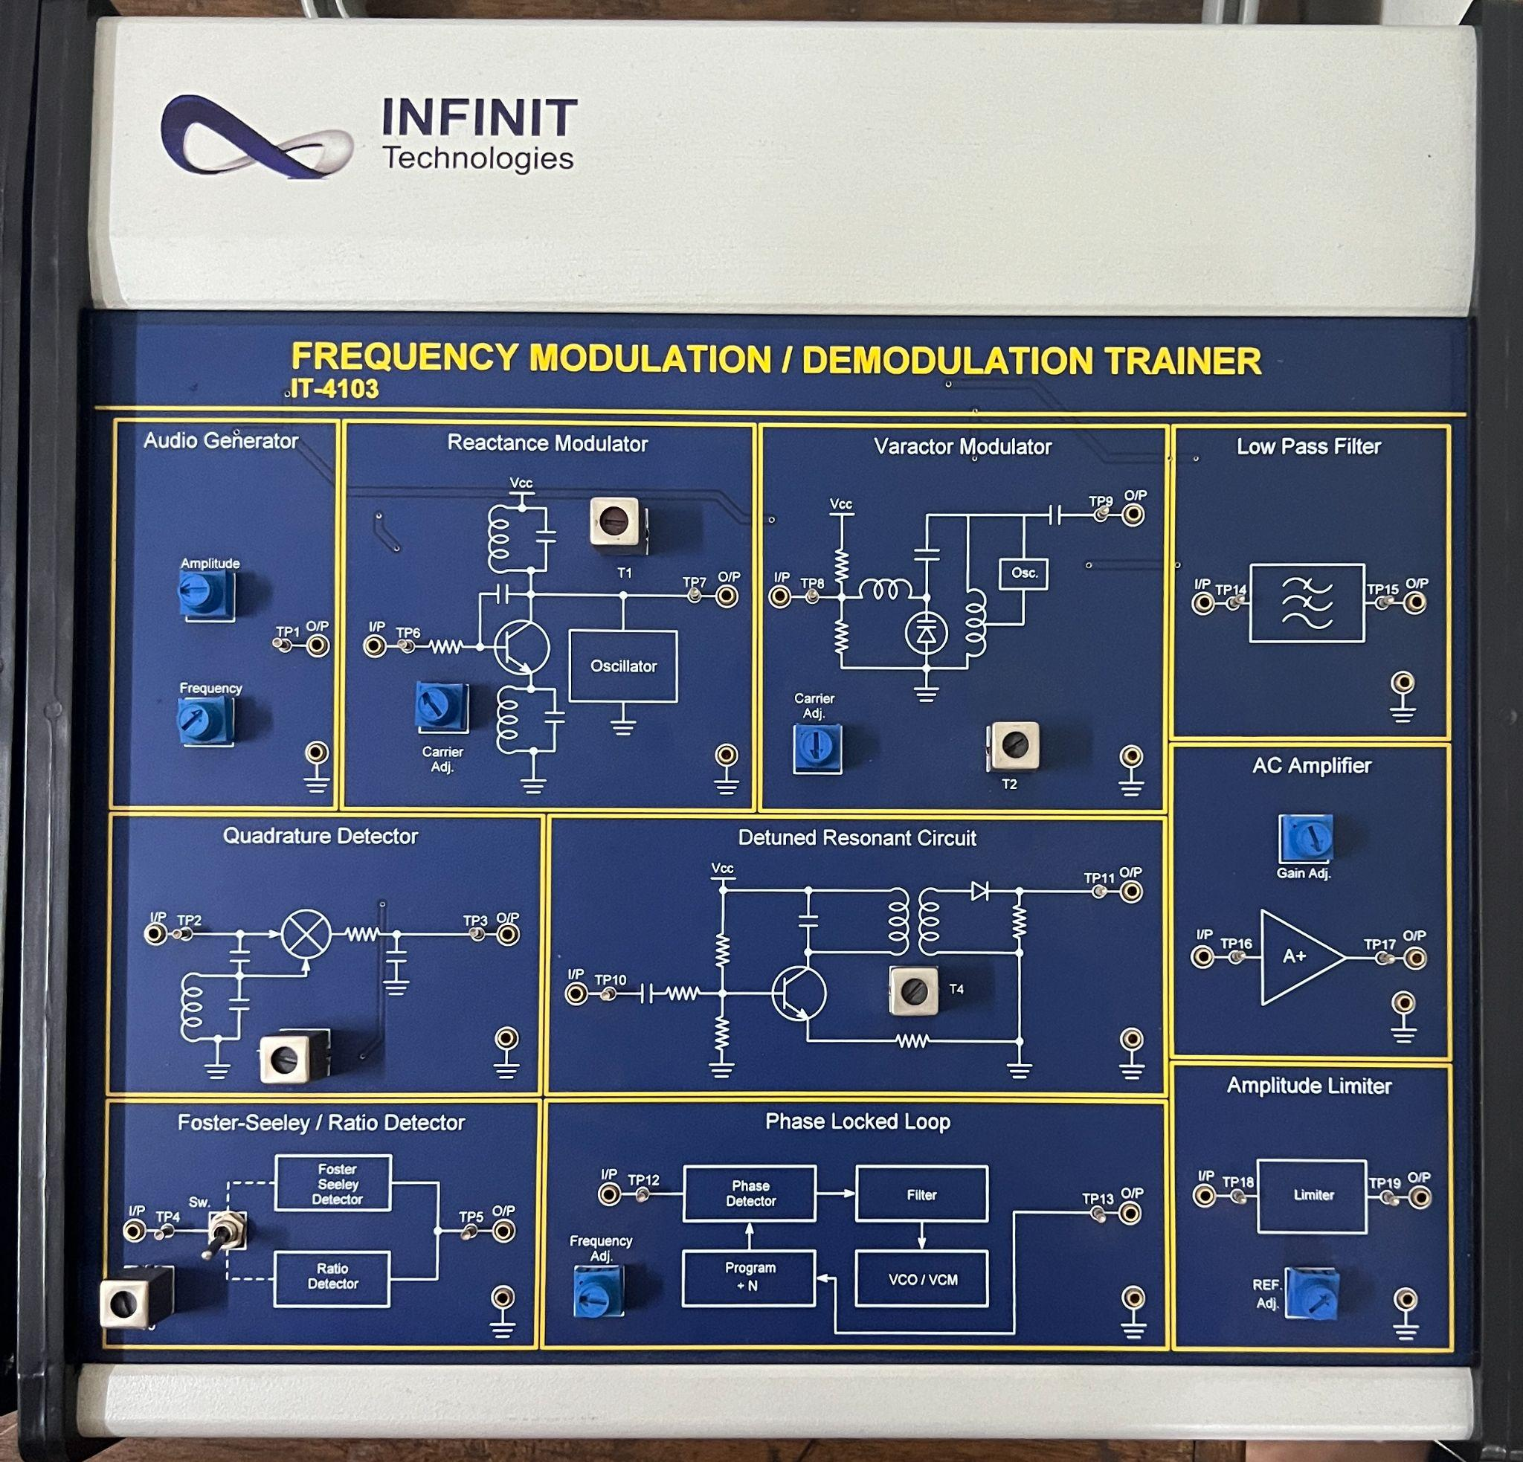

**2. AM DSB/SSB RECEIVER TRAINER IT-1102**

* **AM Antenna:** Captures radio frequency signals from the air.
* **AM Mixer & Local Oscillator:** Mixes the incoming signal with a local oscillator signal to convert it to an intermediate frequency (IF).
* **IF AM Double Side Band:** Intermediate frequency stage for double sideband AM signals.
* **Product Detector:** Demodulates the AM signal to recover the audio signal.
* **455KHz Local Oscillator:** Generates a stable frequency used in the mixing process.
* **Single Side Band Low Pass Filter:** Filters out unwanted frequencies from the SSB signal.
* **Audio Amplifier:** Amplifies the audio signal for output.
* **Speaker:** Outputs the demodulated audio signal.

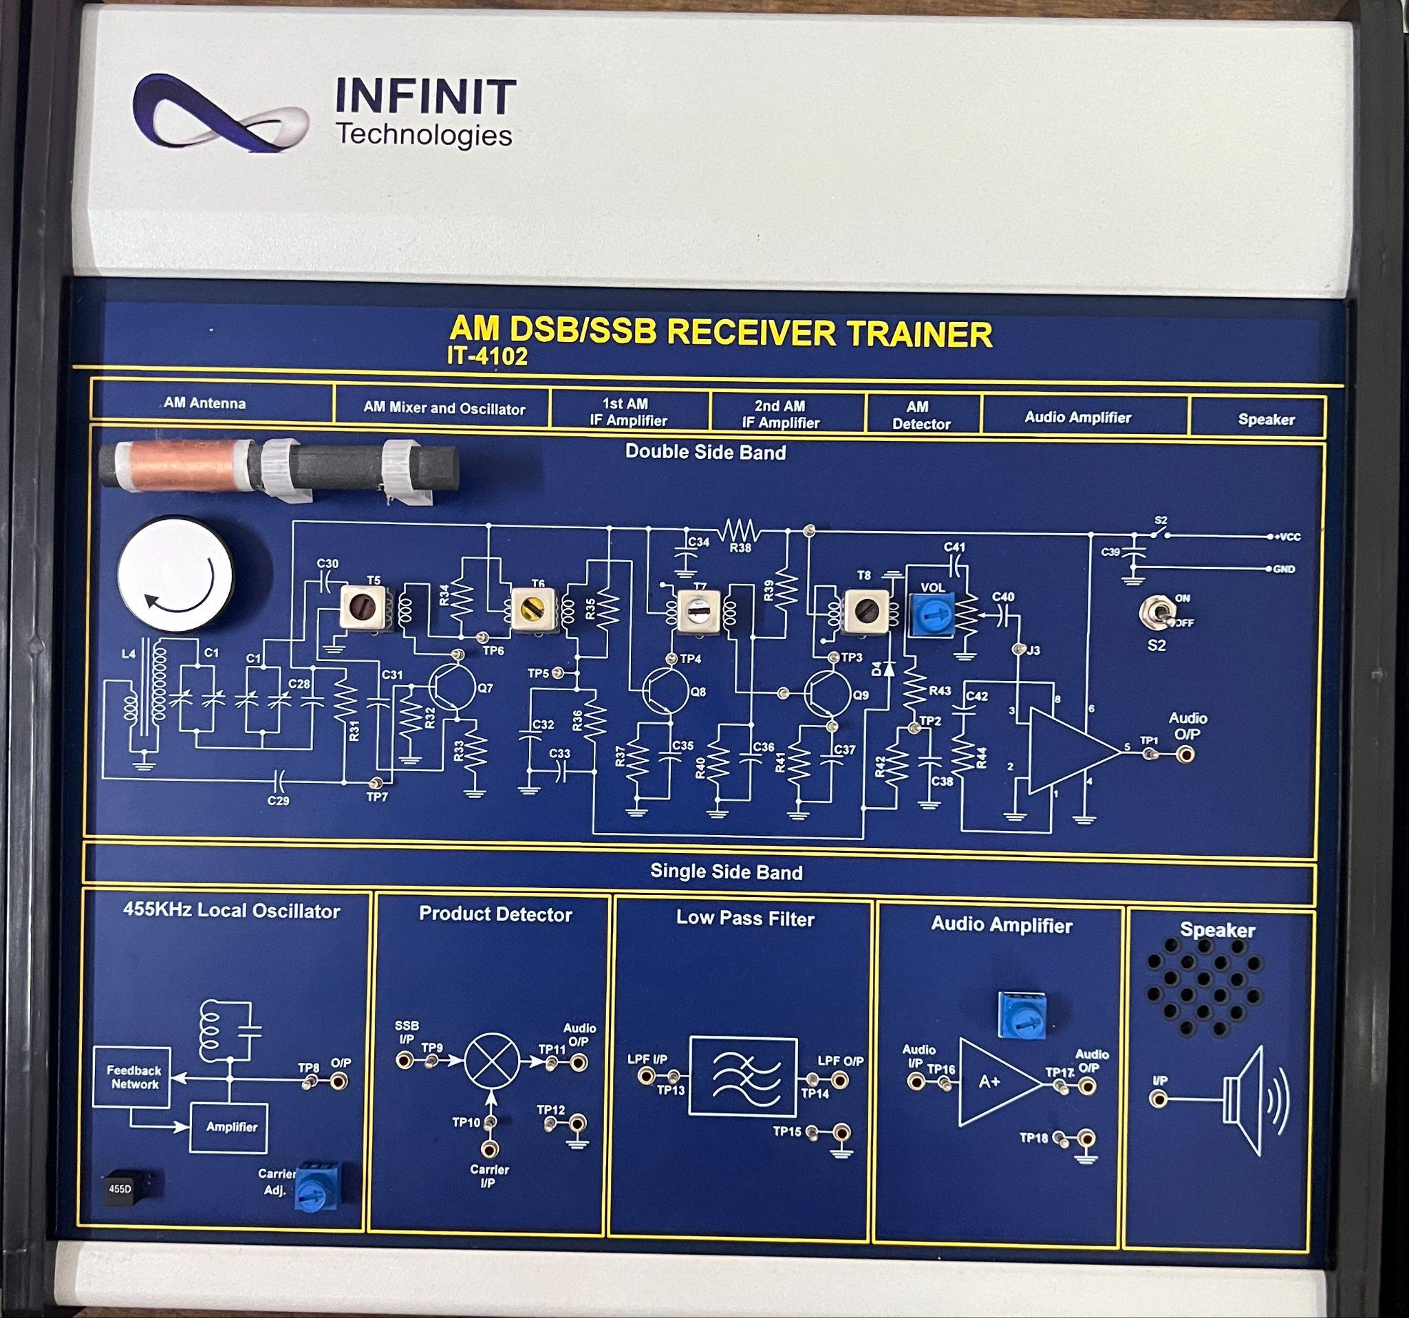

**3. Pulse Code Modulation (PCM) Receiver Trainer, IT-4204**

* **PCM Demodulator:** This section includes a clock, frame sync, and a digital to analog converter. It’s responsible for converting the received PCM signal back into an analog signal.
* **Audio Amplifier:** Amplifies the audio signal after demodulation for output through a speaker.
* **PC Interface (Receiver):** Allows the module to interface with a computer, typically through a USB connection.
* **AC Amplifier:** Amplifies the alternating current (AC) signals within the module.
* **Lowpass Filter:** Filters out high-frequency noise from the demodulated signal to improve the quality of the output audio signal.

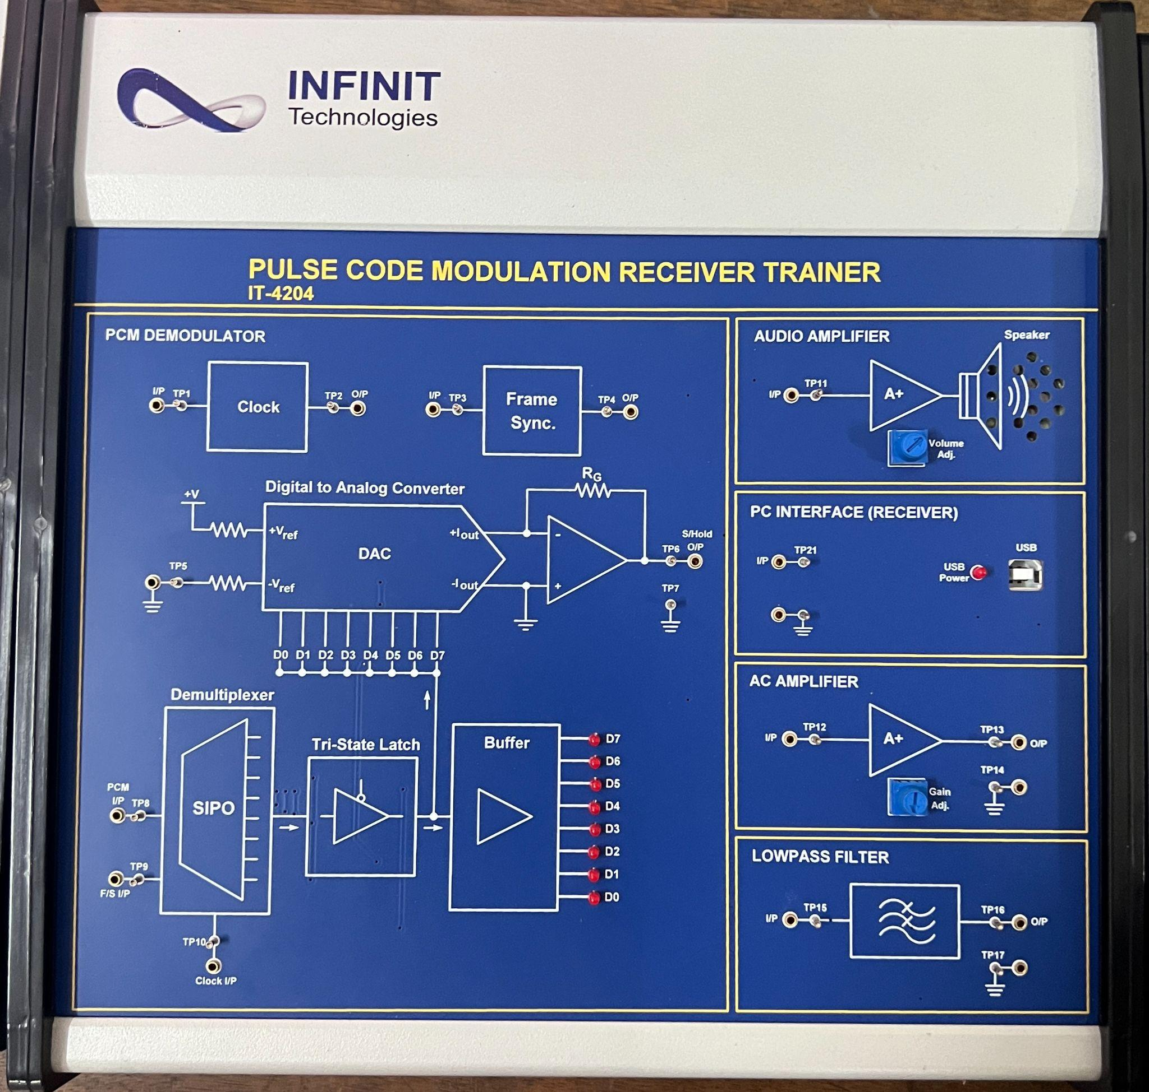

**4. Time Division Multiplexing Transceiver Trainer IT-4202**

* **Transmitter Section:**
* **Function Generator:** Generates various analog signals for transmission.
* **Clock Generator:** Provides timing signals for synchronization.
* **Sampling:** Takes samples of the analog signals at specific intervals.
* **Multiplexer (MUX):** Combines multiple signal samples into one signal for transmission.
* **3-Bit Counter:** Used for addressing in the multiplexing process.
* **Receiver Section:**
* **Demultiplexer (DEMUX):** Separates the combined signal back into individual signal samples.
* **Lowpass Filters:** Filters out high-frequency components to recover the original analog signals.
* **Clock Generator:** Provides timing signals for synchronization in the receiver.

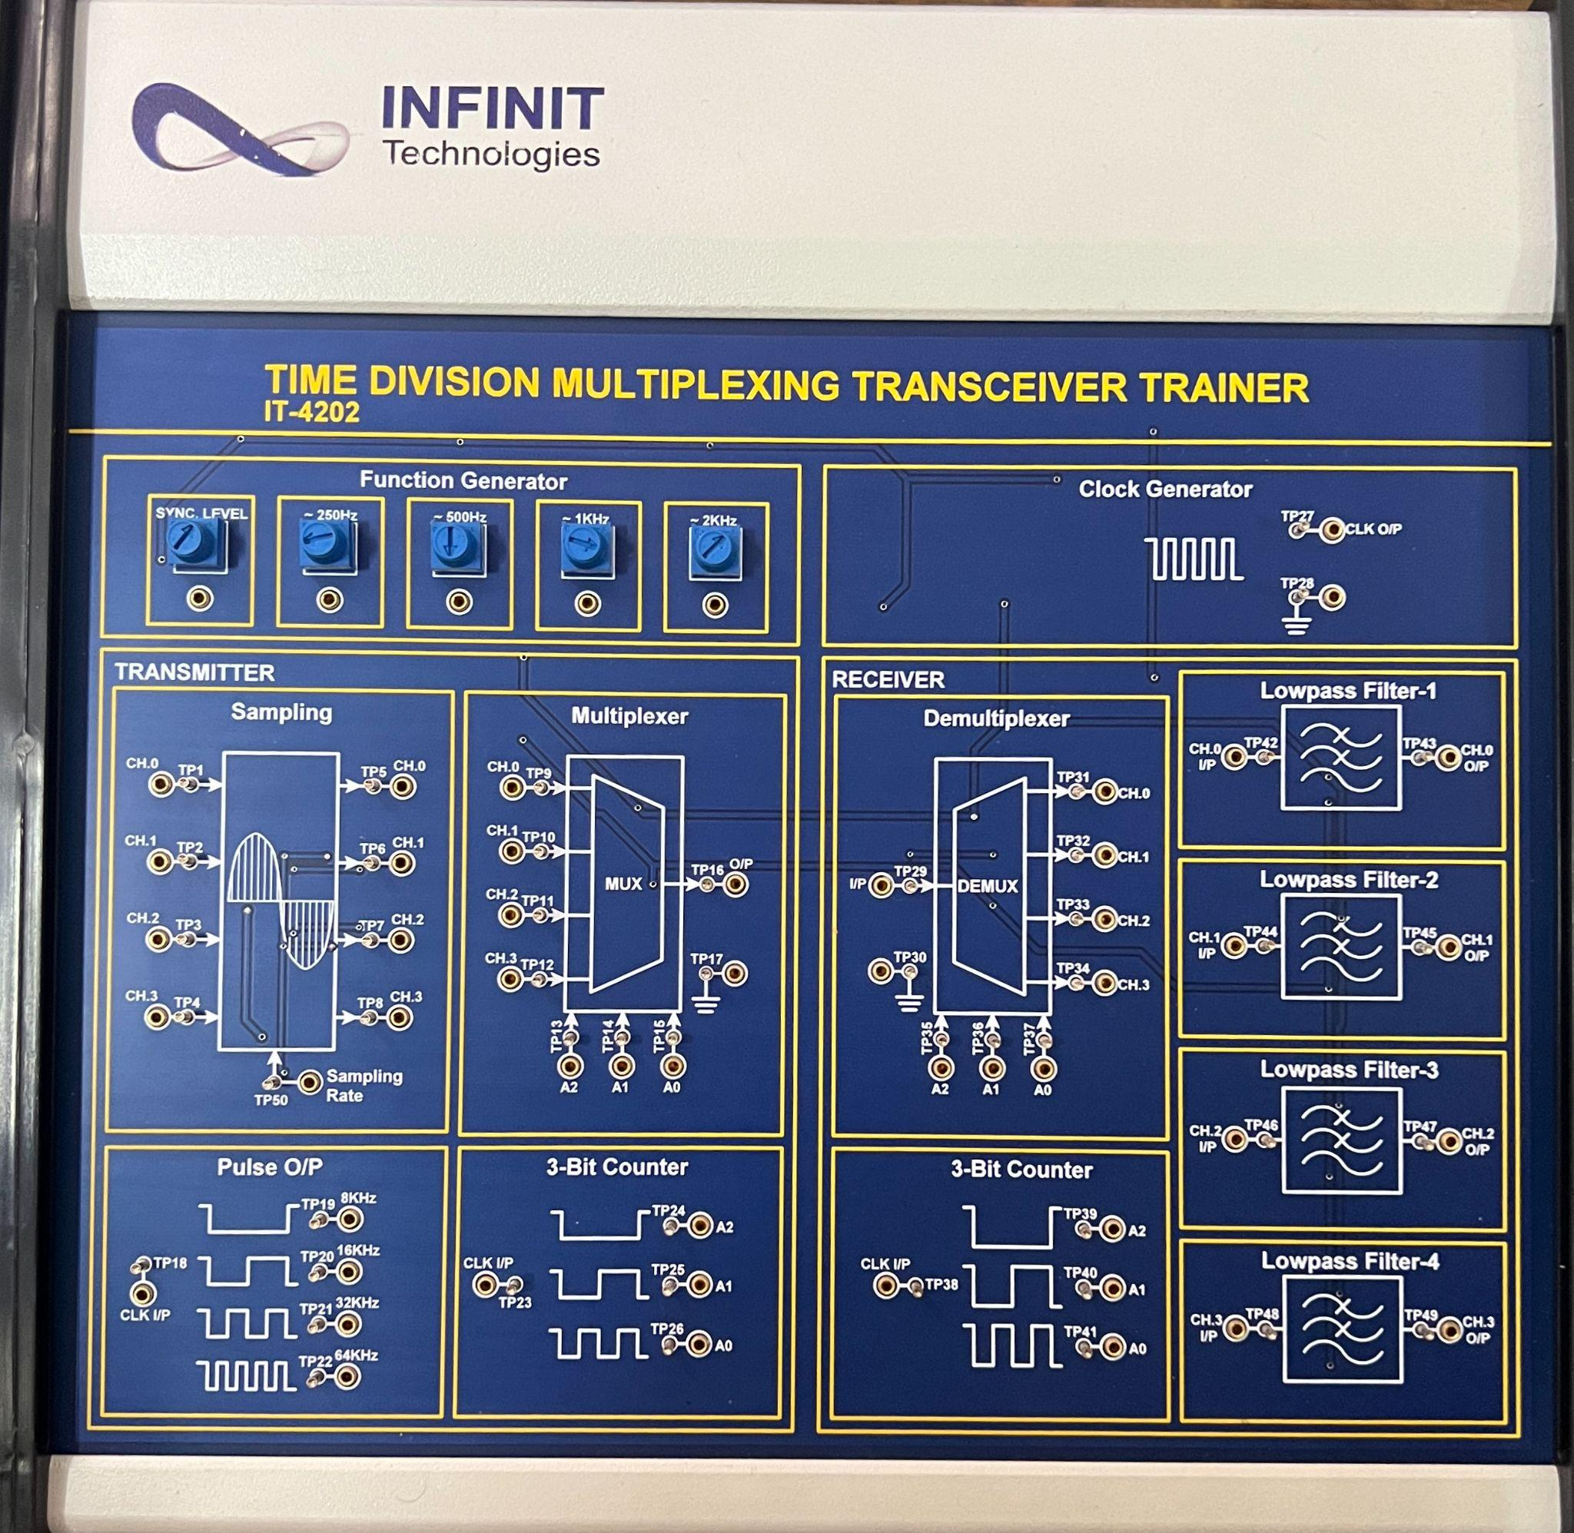

**5. AM DSB/SSB TRANSMITTER TRAINER IT-4101**

* **456kHz Local Oscillator:** Provides a stable frequency for the modulator.
* **Power Amplifier:** Amplifies the modulated signal for transmission.
* **Antenna:** Transmits the amplified signal.
* **Balanced Modulator-1 & 2:** Modulate the audio signal with the carrier frequency.
* **Carrier Oscillator:** Generates the carrier signal for modulation.
* **Audio Amplifier:** Amplifies the audio signal before modulation.
* **MIC Interface:** Allows for microphone input.
* **Ceramic Bandpass Filter:** Filters the signal to the desired frequency band.
* **Speaker:** Outputs the audio signal.

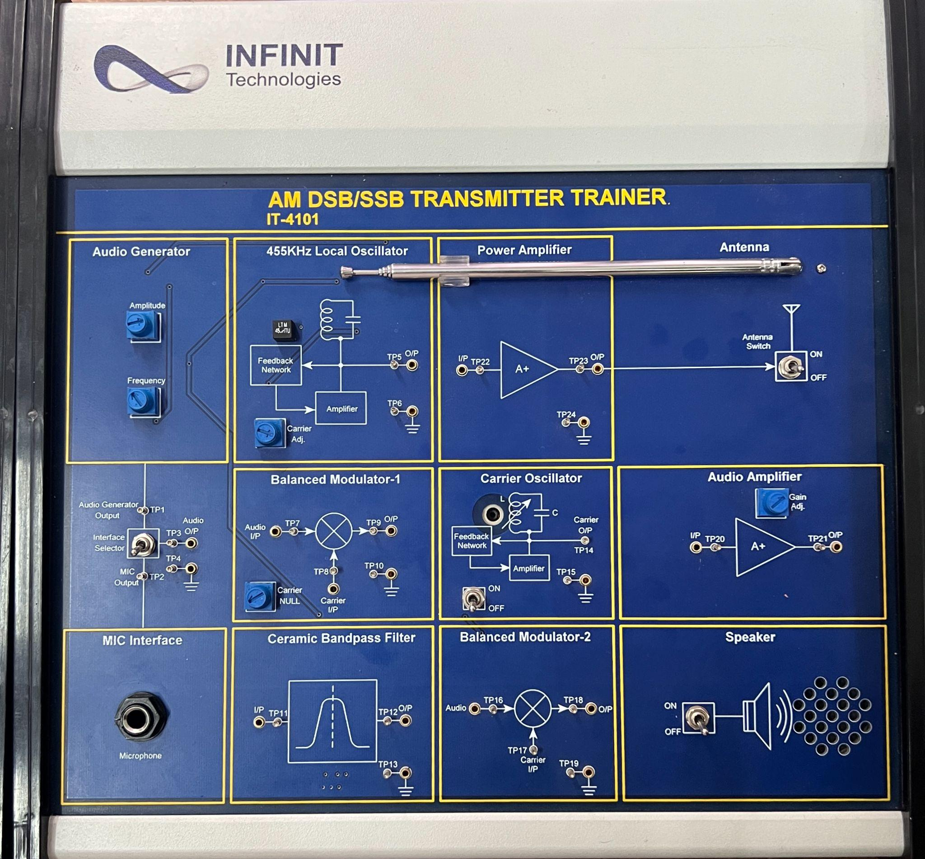

**6. SIGNAL SAMPLING & RECONSTRUCTION TRAINER IT-2201**

* **Channel Selection:** Allows selection between different input channels.
* **Duty Cycle Control:** Adjusts the duty cycle of the sampling signal.
* **AC Amplifiers:** Amplify the audio signals before and after sampling.
* **Sampling Section:** Includes a Sample & Hold circuit that samples the input signal at set intervals.
* **Lowpass Filters:** Filter out high-frequency components after reconstruction to recover the original signal.

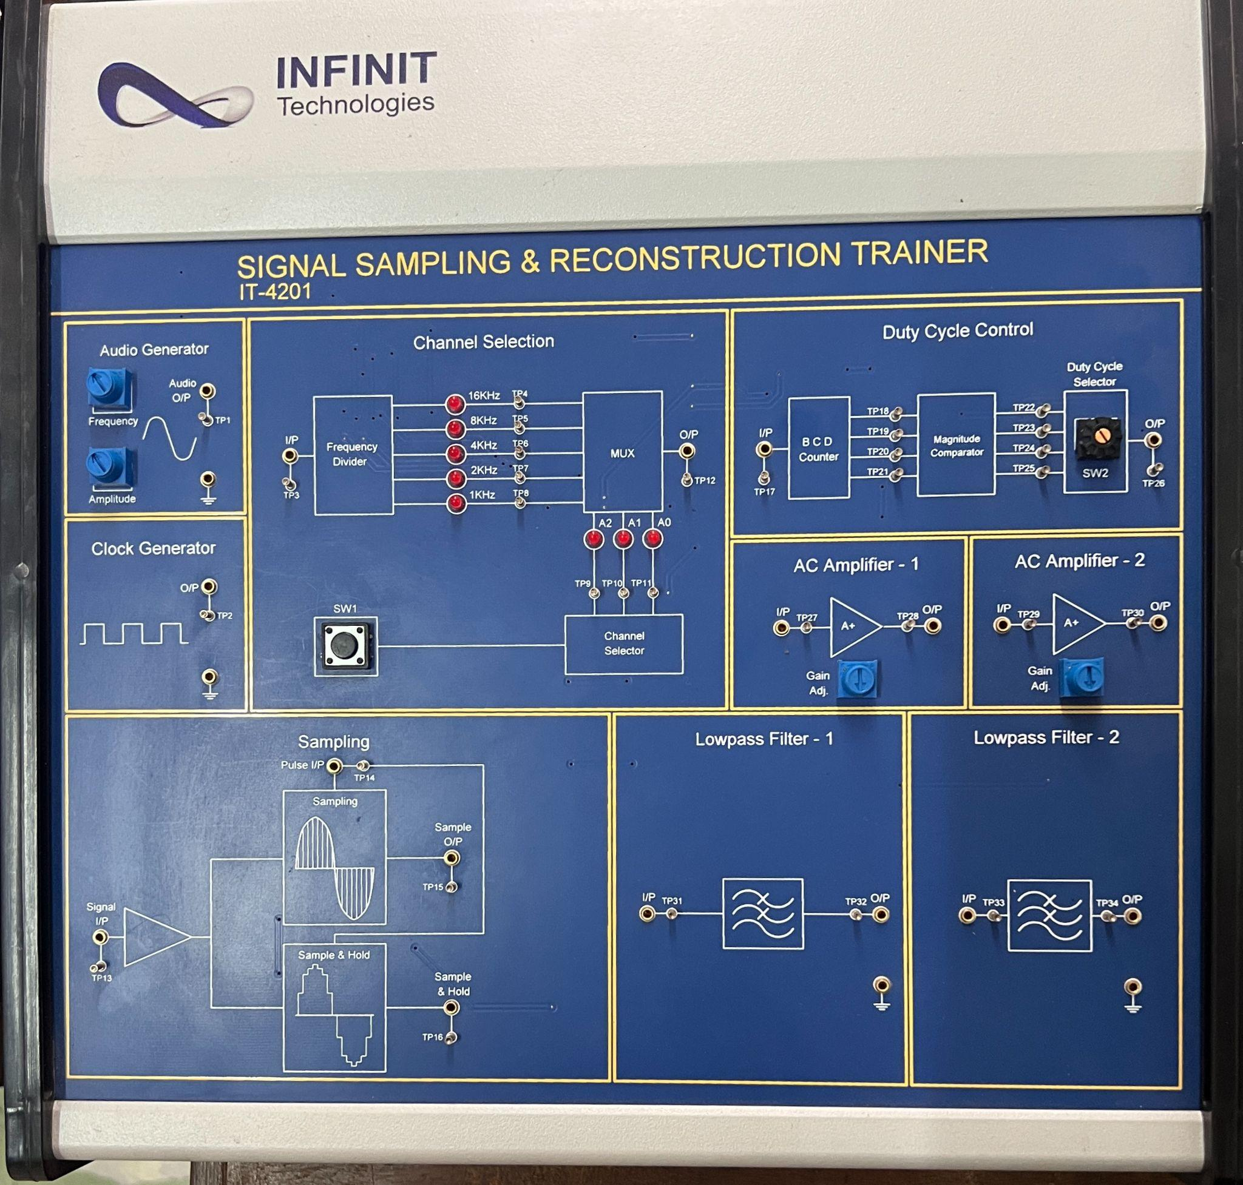

**7. Pulse Code Modulation Transmitter Trainer IT-4203**

* **MIC Interface:** Allows connection of a microphone for audio input.
* **PC Interface (Transmitter):** Facilitates connection to a computer, likely for data transfer or control.
* **DC Level:** Adjusts the direct current (DC) level in the signal.
* **PCM Modulator:**
* **Analog to Digital Converter:** Converts the analog audio signal into a digital format.
* **Tri-State Latch:** Temporarily holds the digital signal.
* **Buffer:** Stabilizes the digital signal before transmission.
* Frame Sync. Generator: Synchronizes the frames of the digital signal.
* **Multiplexer:** Combines multiple digital signals into one for transmission.
* **PISO (Parallel In Serial Out):** Converts parallel data into a serial data stream.
* **Sample and Hold:** Captures the audio signal at specific intervals for processing.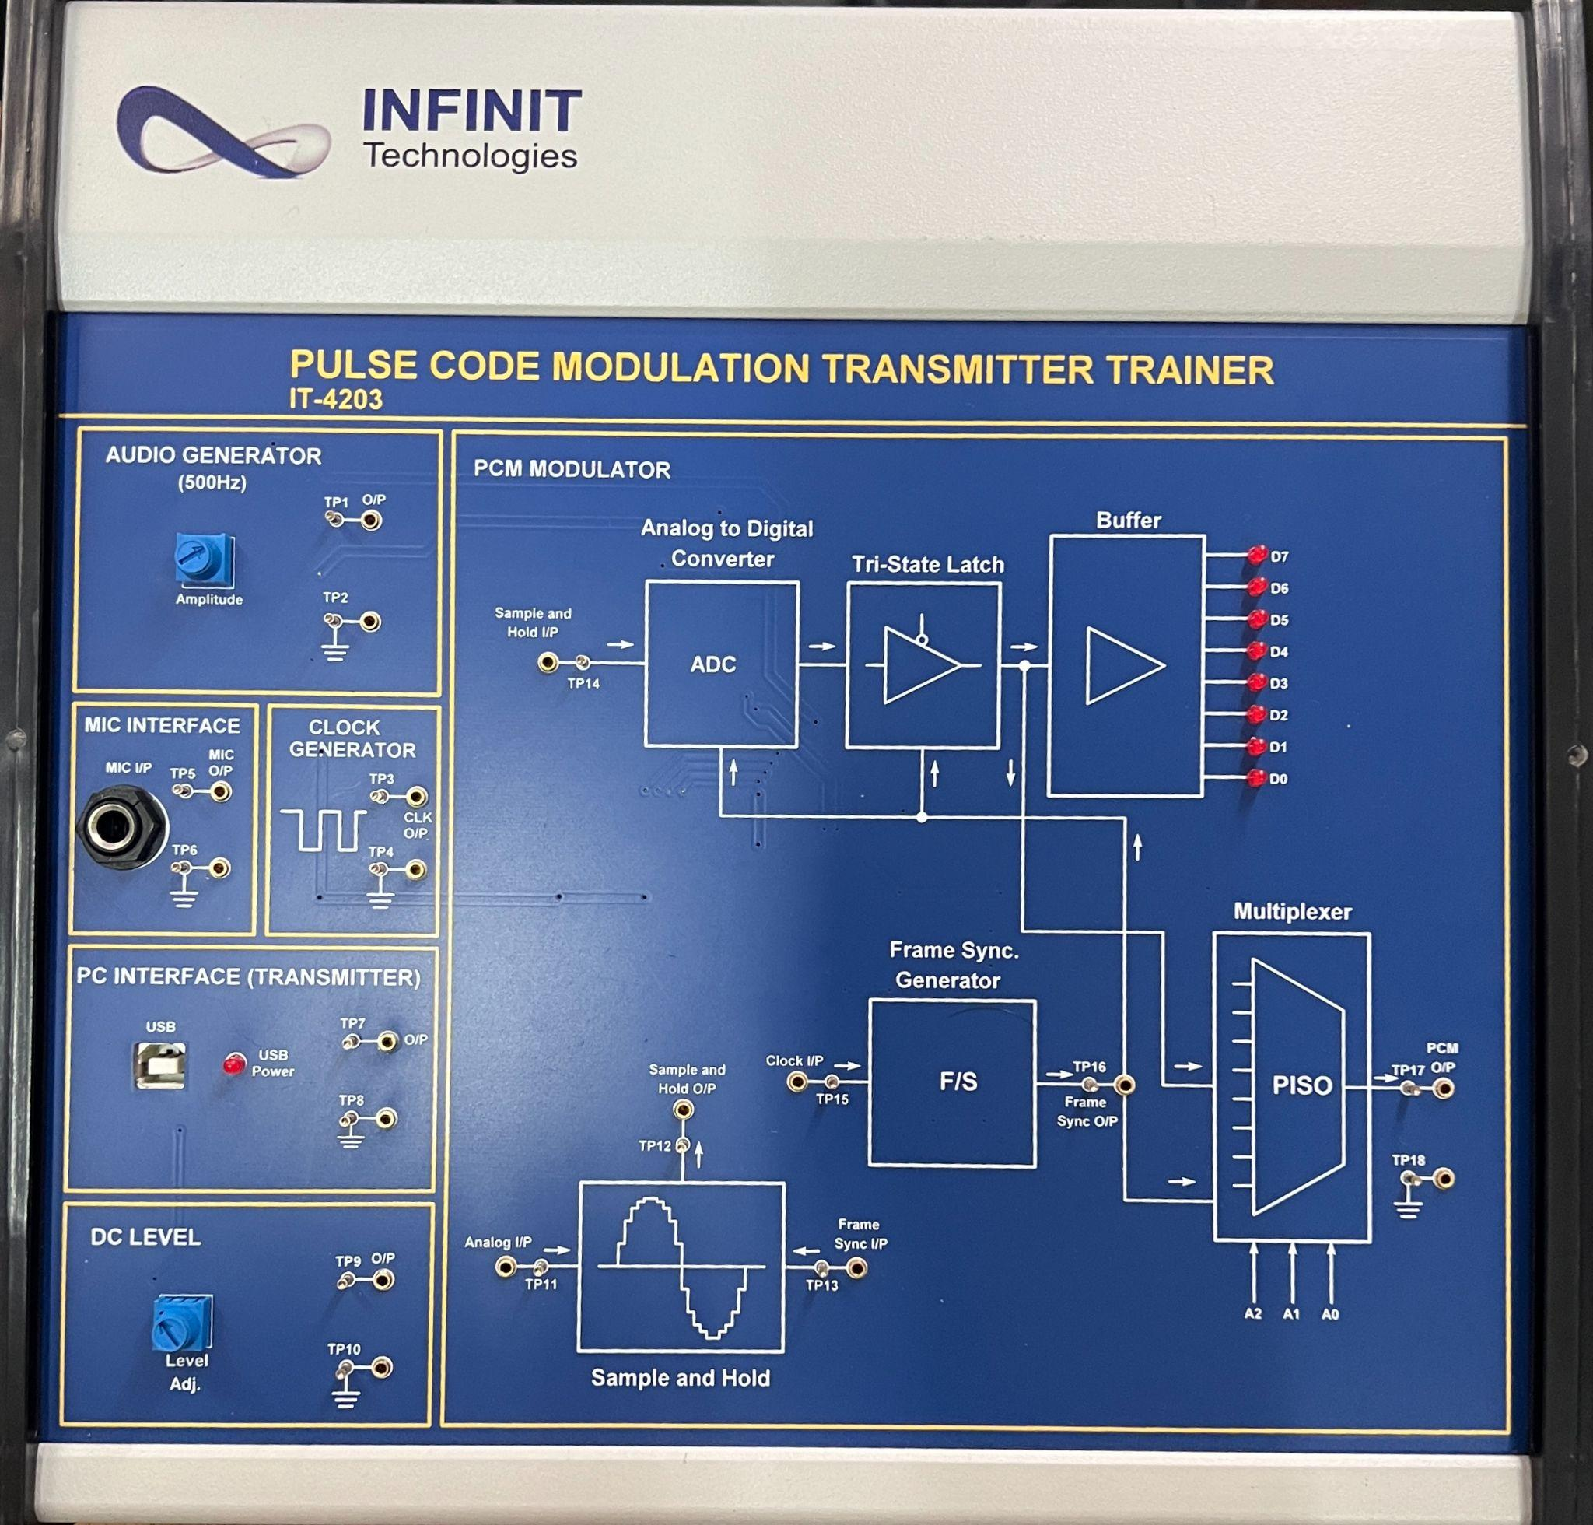

**Discussion:**

In this Communication Engineering Laboratory experiment, we explored key components essential for communication systems. Through trainers like the Frequency Modulator/Demodulator (IT-4103), AM DSB/SSB Receiver (IT-1102), PCM Receiver (IT-4204), Time Division Multiplexing Transceiver (IT-4202), AM DSB/SSB Transmitter (IT-4101), Signal Sampling & Reconstruction (IT-2201), and PCM Transmitter (IT-4203), we grasped modulation, demodulation, multiplexing, and sampling principles. The trainers illustrated functions like reactance modulation, demodulation techniques, clock synchronization, and digital conversion. From multiplexing to signal transmission, each component showcased the intricate processes involved in communication systems. This hands-on experience deepened our understanding of communication fundamentals and their real-world applications, laying a solid foundation for further study and experimentation in the field.